Peri_Urban:

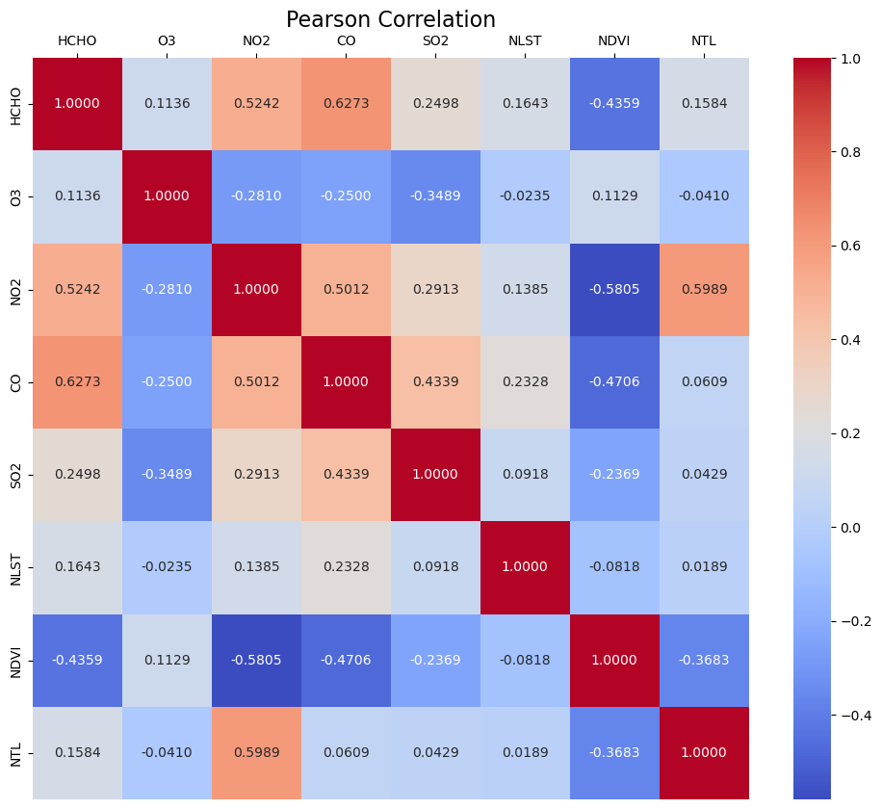

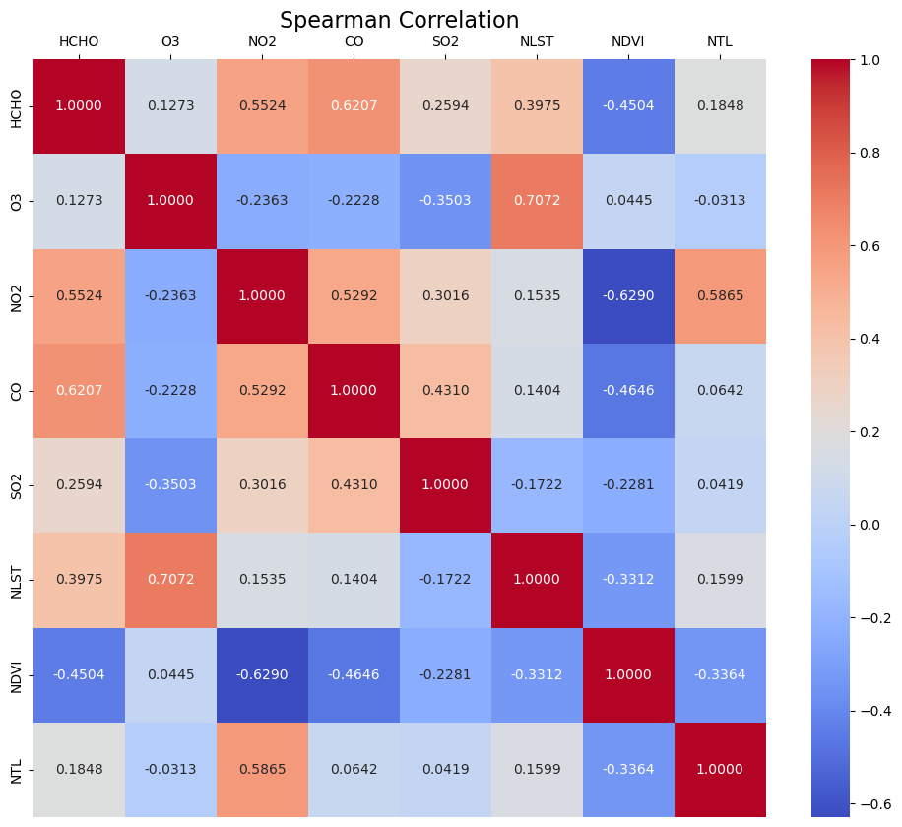

Coefficients: NDVI: -0.36849076 , NLST: 0.24768784 , NTL: 0.14398497

Average Air pollution = -0.36849076 NDVI + 0.24768784 NLST + 0.14398497 NTL

HCHO = -0.54803399 NDVI + 0.3828016 NLST + 0.12713639 NTL

O3 = 0.10518881 NDVI + 0.0220725 NLST + -0.20184804 NTL

NO2 = -0.66272725 NDVI + 0.25206112 NLST + 0.34589634 NTL

CO = -0.47423755 NDVI + 0.42553495 NLST + 0.0817874 NTL

SO2 = -0.26264385 NDVI + 0.15596901 NLST + 0.36695277 NTL

Urban:

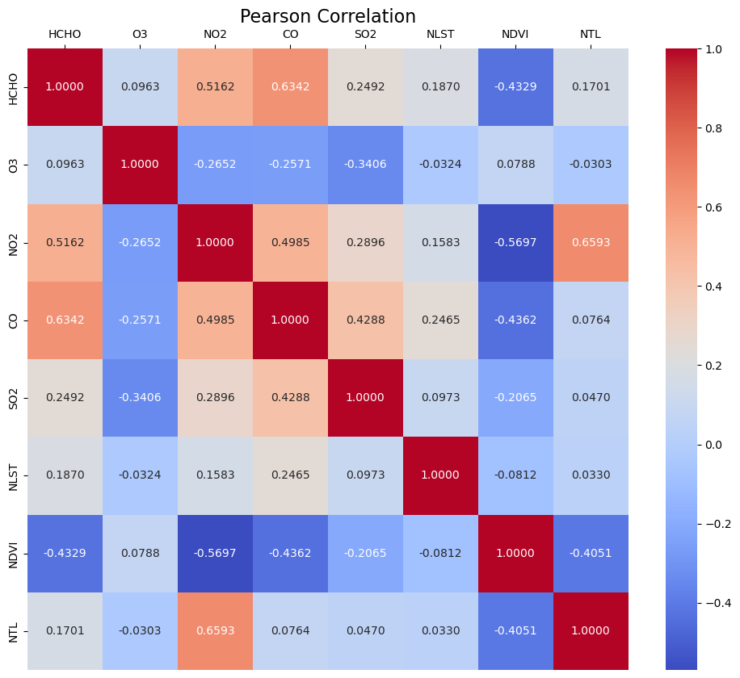

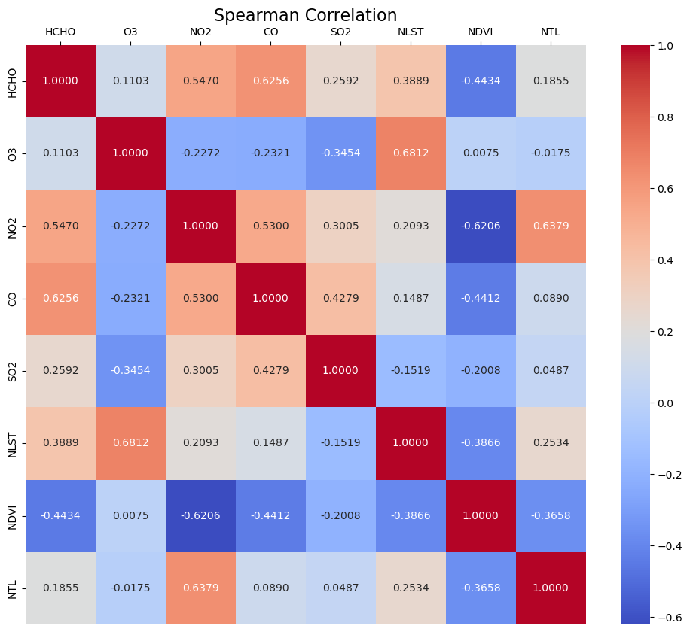

Coefficients: NDVI: -0.33721876 , NLST: 0.26565608 , NTL: 0.14191767

Average Air pollution = -0.33721876 NDVI + 0.26565608 NLST + 0.14191767 NTL

HCHO = -0.51383032 NDVI + 0.39925157 NLST + 0.11430383 NTL

O3 = 0.05995712 NDVI + -0.00199974 NLST + -0.22468455 NTL

NO2 = -0.59046893 NDVI + 0.27981485 NLST + 0.36178843 NTL

CO = -0.41956704 NDVI + 0.46634887 NLST + 0.05952221 NTL

SO2 = -0.22218461 NDVI + 0.18486485 NLST + 0.39865843 NTL